**DAILY ONLINE ACTIVITIES SUMMARY**

|  |  |  |  |  |  |  |
| --- | --- | --- | --- | --- | --- | --- |
| **Date:** | | **4 JULY 2020** | **Name:** | | **KHATHEEJA SAFREENA.** | |
| **Sem & Sec** | | **4th SEM 'A' Section** | **USN:** | | **4AL18CS037.** | |
| **Online Test Summary** | | | | | | |
| **Subject** | N/A | | | | | |
| **Max. Marks** | N/A | | | **Score** | N/A | |
| **Certification Course Summary** | | | | | | |
| **Course** | | **FUNDAMENTALS OF DIGITAL MARKETING.** | | | | |
| **Certificate Provider** | | **Google digital garage.** | | **Duration** | | **40 hour** |
| **Coding Challenges** | | | | | | |
| **Problem Statement: 2 problems uploaded.**  .  For example | | | | | | |
| **Status: completed** | | | | | | |
| **Uploaded the report in Github** | | | | **Yes** | | |
| **If yes Repository name** | | | | **[http://shafreenasharief / lockdown-coding](http://shafreenasharief / lockdown-coding" \o "http://shafreenasharief / lockdown-coding)** | | |
| **Uploaded the report in slack** | | | | **Yes** | | |

Certification Course Details: (Attach the snapshot and briefly write the report for the same)

Coding Challenges Details: (Attach the snapshot and briefly write the report for the same)

**CERTIFICATION COURSE SUMMARY:**

Today I started new course **FUNDAMENTALS DIGITAL MARKETING** through **GOOGLE** **DIGITAL GARAGE** the course is secluded for 6hrs. After the completion of course, certificate will be provided. I completed all the module .I attempted quiz ,which gave me a clear veiw about the topics that were thought and discussed.It consists of 7 modules which also include assessments.



**CODING CHALLENGES DETAILS:**

Today I solved 1 coding challenge,

1. Given an array of integer arr[] and an integer k, the task is to find the median of each window of size k starting from the left and moving towards the right by one position each time.

Examples:

Input:

arr[] = {-1, 5, 13, 8, 2, 3, 3, 1}

k = 3

Output:

5 8 8 3 3 3

Input:

arr[] = {-1, 5, 13, 8, 2, 3, 3, 1},

k = 4

Output:

6.5 6.5 5.5 3.0 2.5

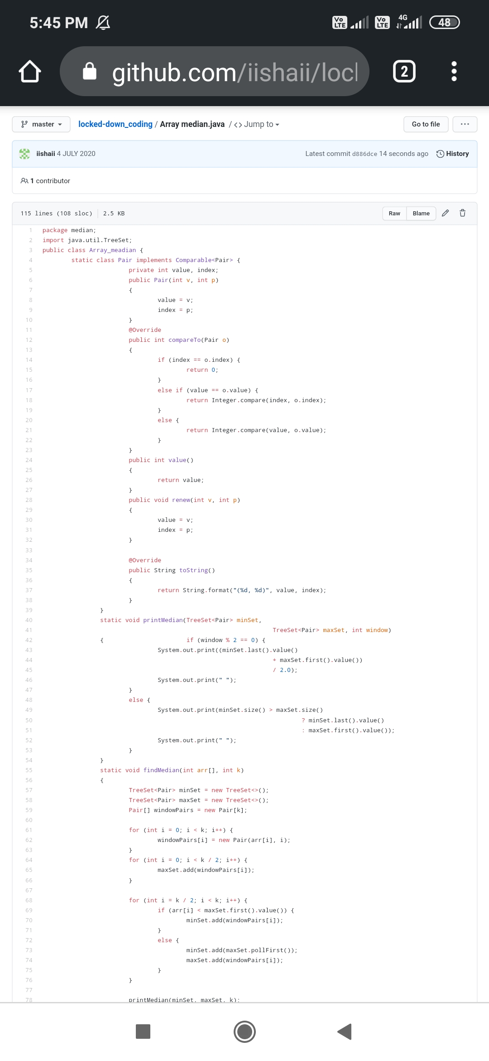

**EXTRA ACTIVITIES**:

Today I have attended the webinar on "**C**” by Ms. Megha Hedge CSE department, AIET. The session was very interesting. There was assessment conducted based on the webinar.

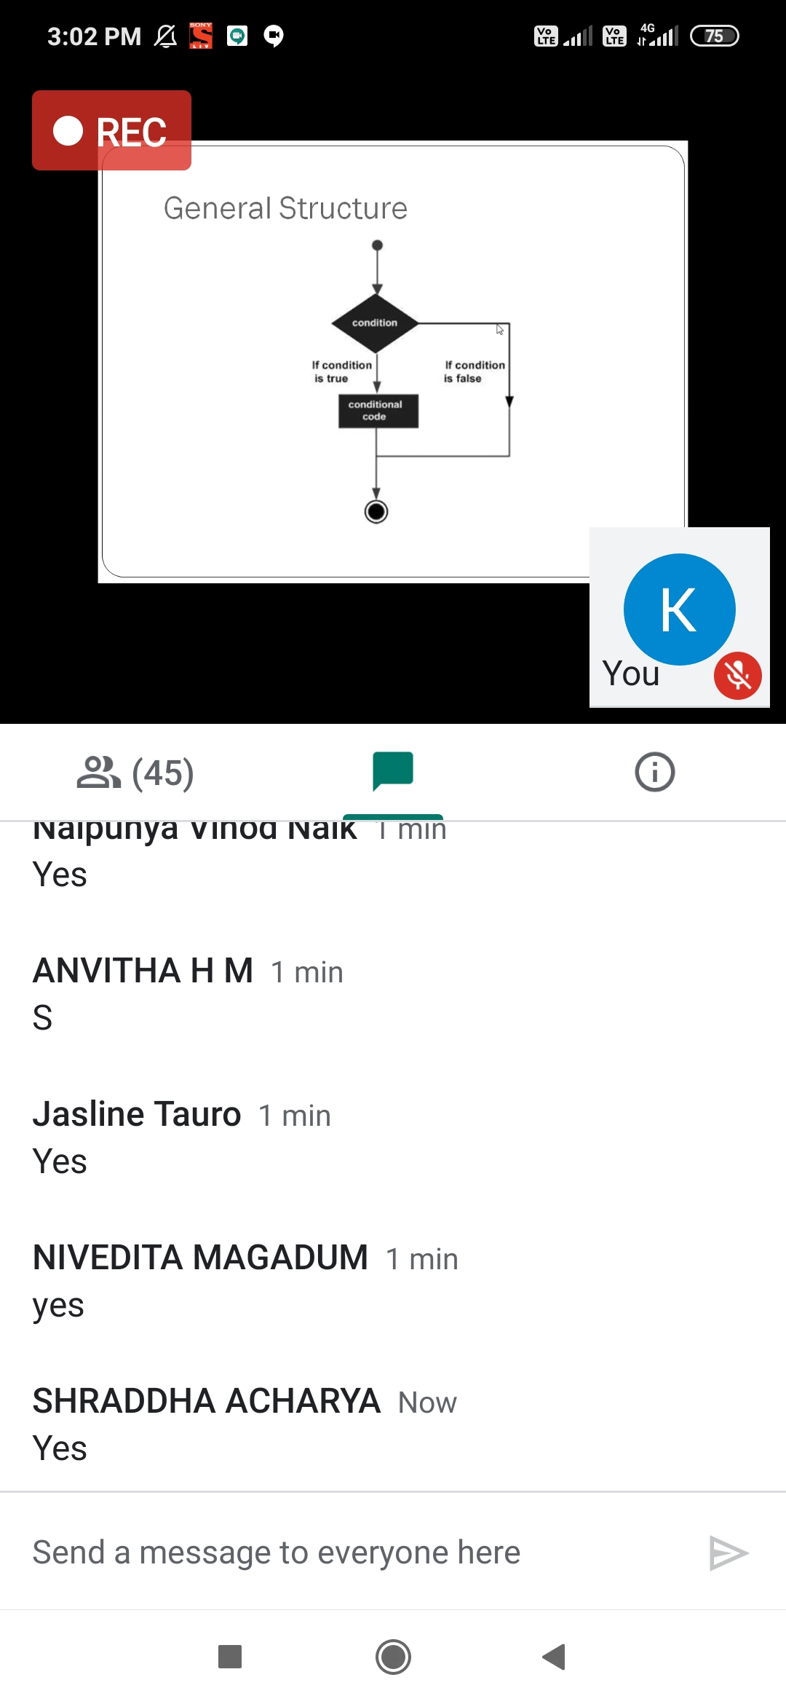

**SOLUTION** : I have uploaded the solution of the above 1 coding problems in my GitHub repository.

http://shafreenasharief / lockdown-coding

[http://shafreenasharief / locked-down--certification-course](http://shafreenasharief / locked-down--certification-course" \o "http://shafreenasharief / locked-down--certification-course)

[http://shafreenasharief / Daily\_Report](http://shafreenasharief / Daily_Report" \o "http://shafreenasharief / Daily_Report)